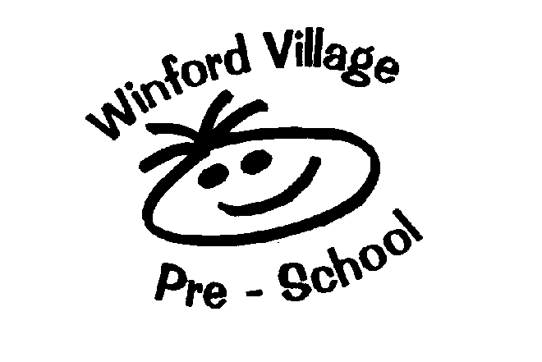
Registered Charity Number - 1072298

Winford Village Pre-School

Food and Drink Policy

Statement of Intent:
This setting regards snacks and meal times as an important part of the setting’s session/day. Eating represents a social time for children and adults and helps children learn about healthy eating.

Aim:
At snack and meal times, we aim to provide nutritious food, which meets the children’s individual dietary needs.

Methods:
Before a child starts to attend the setting, we find out from parents their children’s dietary needs and preferences, including any allergies.

We record information about each child’s dietary needs in his/her registration record and parents sign the record to signify that it is correct.

We regularly consult with parents to ensure that our records of their children’s dietary needs – including any allergies – are up to date. Changes to records are written by parents and attached to the registration forms.

We implement systems to ensure that children receive only food and drink that is consistent with their dietary needs and preferences as well as their parent’s wishes.

We provide nutritious food as snacks, and encourage this at lunchtimes by encouraging lunches to avoid large quantities of fat, sugar and salt and artificial additives, preservatives and colourings.

We encourage parents/carers to include a variety of foods from the four main groups in their child’s packed lunch:
- Meat, fish and protein alternatives
- Dairy foods
- Grains, cereals and starch vegetables; and
- Fruit and vegetables.

We include foods from a range of cultural backgrounds, providing children with familiar foods and introducing them to new ones.

We take care not to provide food containing nuts or nut products and are especially vigilant where we have a child who has a known allergy to nuts.

Through discussion with parents, and research reading by staff, we obtain information about the dietary rules of the religious groups to which children and their parents belong, and of vegetarians and vegans, and about food allergies. We take account of this information in the provision of food and drinks.

- We require staff to show sensitivity in providing for children’s diets and allergies. Staff do not use a child’s diet or allergy as a label for the child or make a child feel singled out because of his/her diet or allergy.
- We organise snack times so that they are social occasions in which children and staff participate.
- We use snack times to help children to develop independence through making choices, serving food and drink and feeding themselves.
- We provide children with utensils that are appropriate for their ages and stages of development and that take account of the eating practices in their cultures.
- We have fresh drinking water constantly available for the children. We inform the children about how to obtain the water and that they can ask for water at any time during the session/day.
- We inform parents who provide food for their children about the storage facilities available in the setting.
- We give parents who provide food for their children information about suitable containers for food.
- In order to protect children with food allergies, we have rules about children sharing and swapping their food with one another.
- For children who drink milk, we provide pasteurised semi-skimmed milk.

The policy was reviewed and revised in November 2024

Next review date: November 2025

Signed:

